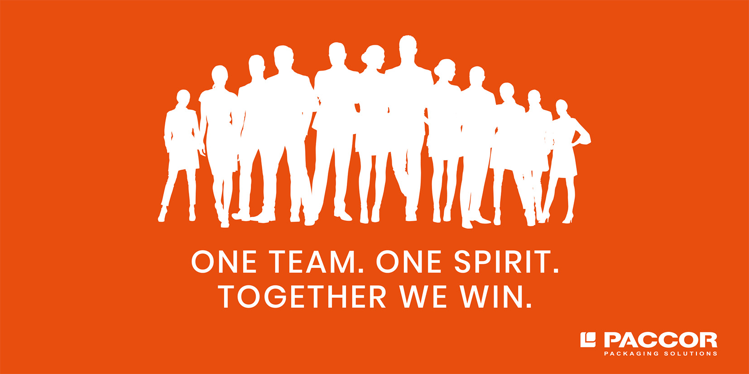

June 2, 2021, Düsseldorf, Germany

PACCOR ANNOUNCES CLOSING OF PREVIOUSLY ANNOUNCED ACQUISITION OF MIKO PAC N.V.

Further to its news release dated March 31, 2021 announcing the signing of a purchase agreement for the acquisition of Miko Pac, PACCOR is pleased to announce that it has closed, on June 1, 2021 its previously announced transaction.

Andreas Schütte, CEO of PACCOR: “We are excited to announce the closing today. With this acquisition, we will continue the execution of our growth strategy.”

Kristof Michielsen, Managing Director of Miko Pac: “We are extremely pleased now to be a part of this business and look forward to making an active contribution to its continued development.”

Karl Hermans, Managing Director of Miko Pac: “We are grateful to PACCOR for its interest and belief in our business, and view our cooperation as an important milestone for our company. I am confident that they will add considerable value to our business, and that together we should be able to ensure our continued profitable growth.”

MEDIA CONTACT:
Sonja Teurezbacher
Vice President Group Communications & Marketing
communication@paccor.com
ABOUT PACCOR
At PACCOR we create innovative and sustainable packaging solutions for the consumer, food, and foodservice market. Our overall goal is to protect what is worth being protected: our planet, our partners’ products, and our employees. We have high expertise in developing and providing valuable rigid plastic packaging products. Our solutions meet current market trends by constantly thinking outside the box. With more than 3,000 dedicated employees in 15 countries, PACCOR is a global player in the packaging industry. Everything we do contributes to the protection and hygienic safety of valuable products. PACCOR leads the transition towards a circular economy. Because we believe this is the best way to achieve real change in the industry and to create shared value for all our stakeholders and society. New York-based investment firm Lindsay Goldberg acquired Coveris Rigid in August 2018 and renamed it PACCOR. More: https://www.paccor.com/

ABOUT MIKO PAC
As a former subsidiary of Miko N.V., Miko Pac has been active in plastics packaging for some 45 years. In 2020, the plastics processing group achieved a turnover of more than 100 million euros and employed about 500 people. Miko Pac has its own production sites in Belgium, Poland, Indonesia, and sales organizations in Germany and France. More: https://mikopac.com/en/

